Microcontroller fire alarm system

Add testing equipment to testing circuit diagram.

System Planning

Problem
Who, What, Why, Where
A small office is in need of a fire alarm & sprinkler system, as the office needs to comply with fire safety regulations. Furthermore, there are valuable prototypes of products that are stored in side the office, which would be destroyed in the event of a fire. An alarm & sprinkler system would stop the fire from the destroying the products.

Specification
At least 3 qualitative and 3 quantitative system specifications (six total).
At least 2 Electronic parameters (e.g. time, frequency, current, voltage, power), including tolerances.

Measure the threshold of the microcontroller to get the +/- information.
(The italic text refers to input & outputs defined in Code Description)
Specifications:
- When the override switch is high the all of the outputs will be forced low
- When sensor one indicator is at +5V± for 500±100ms, the sensor one sprinkler will be +5V±
- When sensor two indicator is at +5V for 500ms or more, the sensor two sprinkler will be +5V
- When sensor three indicator is at +5V for 500ms or more, the sensor three sprinkler will be +5V
- When sensor one is triggered then the LED associated to sensor one indicator will be illuminated.
- When sensor two is triggered then the LED associated to sensor two indicator will be illuminated.
- When sensor three is triggered then the LED associated to sensor three indicator will be illuminated.

System Development
Use subroutines
Try to use Analogue To Digital converter

Flowchart
Produce a flowchart that is clearly annotated & shows the structure of the program.
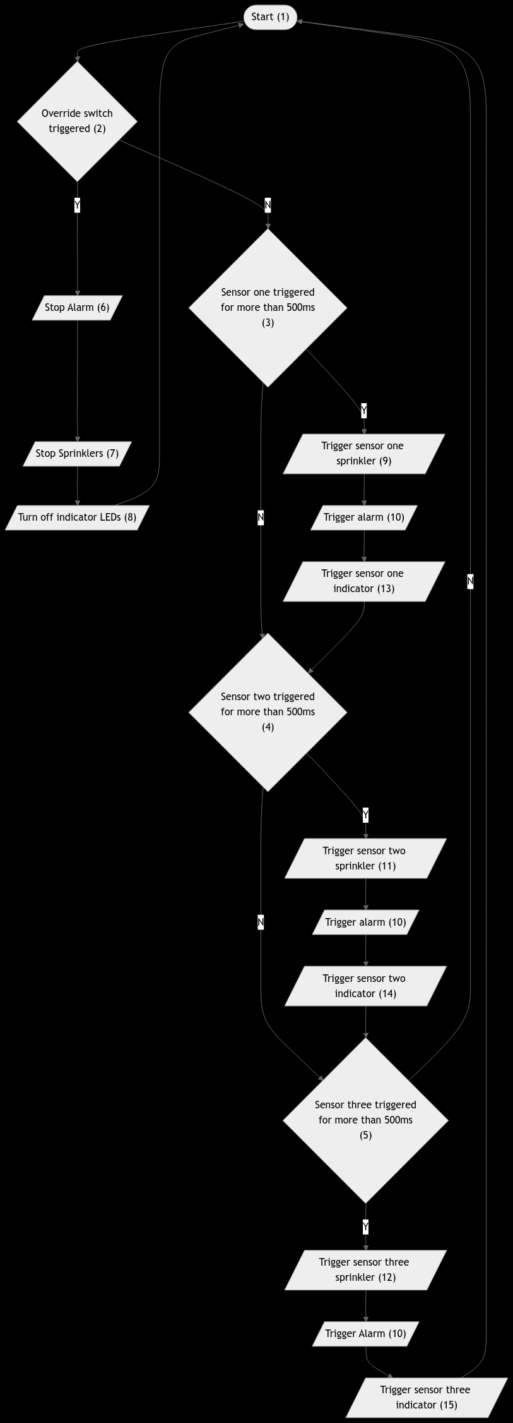
(See Specification for information on tolerances). (The italic text refers to input & outputs defined in Code Description).
1: This is the start of the program & where all loops lead back to.
2: This checks if the override switch is pressed, if it’s not then the sensors will be checked. If it has then it will eventually return back to the start without passing through the sensor checks so they cannot be triggered.
3: Checks if sensor one has been triggered for over 500ms. The reason that it makes sure it has been triggered for over 500ms is to make sure false positives from a singular voltage spike cannot cause it to trigger erroneously.
4: Checks if sensor two has been triggered for over 500ms. The reason that it makes sure it has been triggered for over 500ms is to make sure false positives from a singular voltage spike cannot cause it to trigger erroneously.
5: Checks if sensor three has been triggered for over 500ms. The reason that it makes sure it has been triggered for over 500ms is to make sure false positives from a singular voltage spike cannot cause it to trigger erroneously.
6: This stops the alarm by setting the alarm output low.
7: This stops the sprinklers by setting sensor one sprinkler, sensor two sprinkler, & sensor three sprinkler to low.
8: This turns of the indicator LEDS by setting sensor one indicator, sensor two indicator, & sensor three indicator to low.
9: This turns on the sensor one sprinkler by setting its output high.
10: This turns on the alarm by setting its output high.
11: This turns on the sensor two sprinkler by setting its output high.
12: This turns on the sensor three sprinkler by setting its output high.
13: This turns on the sensor one indicator by setting its output high.
14: This turns on the sensor two indicator by setting its output high.
15: This turns on the sensor three indicator by setting its output high.

Code Description
What does the code do?
Including at lest 5 input & output bits.

Could add water pressure sensors for sprinklers?
Inputs:
A.1 (override switch):
- Low = Normal function
- High = Force B.0-6 Low
A.0 (sensor one):
- Low = Sensor one idle
- High = Sensor one triggered
A.7 (sensor two):
- Low = Sensor two idle
- High = Sensor two triggered
A.6 (sensor three):
- Low = Sensor three idle
- High = Sensor three triggered

Outputs:
B.0 (alarm):
- Low = Alarm idle
- High = Alarm triggered
B.1 (sensor one indicator):
- Low = Sensor one idle
- High = Sensor one triggered
B.2 (sensor two indicator):
- Low = Sensor two idle
- High = Sensor two triggered
B.3 (sensor three indicator):
- Low = Sensor three idle
- High = Sensor three triggered
B.4 (sensor one sprinkler):
- Low = Sensor one sprinkler idle
- High = Sensor one sprinkler triggered
B.5 (sensor two sprinkler):
- Low = Sensor two sprinkler idle
- High = Sensor two sprinkler triggered
B.6 (sensor three sprinkler):
- Low = Sensor three sprinkler idle
- High = Sensor three sprinkler triggered

A summary of the code is, every 100ms it checks if any of the sprinklers are high or if the override switch has been pressed. If the override switch has been pressed, it skips checking any of the sensors & forces the outputs to low, stopping any ongoing alarms. If the switch has not been pressed, then if a sensor is triggered it increments a counter every 100ms & when the counter reaches 5 the sensor is triggered. If a sensor has no been triggered its counter is reset to 0, this ensures that the alarm only triggers after the sensor has been triggered 5 times consecutively.
The code is structured this way so that when one sensor triggers the microcontroller is not stuck only monitoring the single sensor. Other sensors can also be triggered during this time, or the override switch can be pressed.

Code
;*******************************************************************
; TEMPLATE PROVIDED BY CENTRE FOR USE WITH HEADER FILE
;
; TITLE: #### Microcontroller fire alarm system #####
; AUTHOR: ######## Tye #########
; DATE: ####### 2024/10/14 ######
;

;******************************************************************
; PROGRAM DESCRIPTION:
;
; #### Checks if a fire has started & triggeres alarms & sprinklers in response #######
;
;******************************************************************

;*********************************************************************
; DEFINITIONS
;*********************************************************************
;The header file can be used with either the PIC16F88 or PIC16F877A
;#define UseRC ; UseRC, UseCrystal or UseInternal - defaults to UseRC
#define UseInternal ; UseRC, UseCrystal or UseInternal - defaults to UseRC
#define UseInterrupt
;#define Watchdog ; The Watchdog timers are off by default unless this is uncommented

;#include "Header.inc" ;Predefined wait subroutines - wait1ms, wait10ms, wait100ms, wait1000ms
;Predefined ADC subroutines - readadc0, readac1, readadc2
; radix dec ; set default number radix to decimal
;radix hex ; set default number radix to hex

;*********************************************************************
; VARIABLES
;*********************************************************************

; #### Create any variables here using the EQU statement
;
;
; #### e.g. myVar equ b1

;*********************************************************************
; MAIN PROGRAM
;*********************************************************************

;****** INITIALISATION ******
clrf PORTA
clrf PORTB ; make sure PORTB output latches are low
bsf STATUS,RP0 ; select register page 1
;Modify the next line to correspond with your input/output requirements
movlw b'11111111' ; set port A data direction (0 = output bit, 1 = input bit)
movwf TRISA ;
;Modify the next line to correspond with your input output reqirements
movlw b'00000000' ; set port B data direction (0 = output bit, 1 = input bit)
movwf TRISB ;
bcf STATUS,RP0 ; select register page 0

;****** MAIN PROGRAM ******
;*************uncomment by removing semicolons from next two lines to use interrupt routine****************

bsf INTCON,INT0IE ; set external interrupt enable
bsf INTCON,GIE ; enable all interrupts

main:
;*********************************************************************

; ---------- Initialisation ----------
init:
; Clears inputs & outputs
clrf PORTB
clrf PORTA

bsf STATUS,RP0 ; Allows writing to TRISx (memory page 1)

; Sets B.x Output
movlw h'00'
movwf TRISB
; Sets A.x Input
movlw h'FF'
movwf TRISA

bcf STATUS,RP0 ; Locks TRISx (memory page 0)

vars:
; Stores how many times each spinkler has been triggered
Sprinkler_One_Count EQU B0
Sprinkler_Two_Count EQU B1
Sprinkler_Three_Count EQU B2

; Stores the result of calculations
Result EQU B3

; Init all vars to 0
movlw h'0'
movwf Sprinkler_One_Count
movwf Sprinkler_Two_Count
movwf Sprinkler_Three_Count
movwf Result

; ---------- Main Cycle ----------
main:
; Test for override.
btfsc PORTA, 0
goto override_switch

; Run spinklers
btfsc PORTA, 1
call spk_one_guard
btfsc PORTA, 2
call spk_two_guard
btfsc PORTA, 3
call spk_three_guard

; Reset spk counts (if appropriate)
btfss PORTA, 1
call zero_spk_one_count
btfss PORTA, 2
call zero_spk_two_count
btfss PORTA, 3
call zero_spk_three_count

; Wait for awhile
call wait100ms

goto main

; ---------- Override Switch ----------
override_switch:
clrf PORTB

; Reset counts for spinkler triggers
movlw h'00'
movwf Sprinkler_One_Count
movwf Sprinkler_Two_Count
movwf Sprinkler_Three_Count
goto main

; ---------- Sprinkler One ----------
spk_one_guard:
; Set Result 0 if count is not 5.
btfss Sprinkler_One_Count, 0
bsf Result, 0
btfss Sprinkler_One_Count, 2
bsf Result, 0

; Increment in place if bellow 5.
btfsc Result, 0
incf Sprinkler_One_Count, 1

; Trigger if 5.
btfss Result, 0
call spk_one_trigger

bcf Result, 0 ; Reset Result reg.
return

spk_one_trigger:
; Trigger,
bsf PORTB, 0 ; Alarm
bsf PORTB, 1 ; Sensor one indicator
bsf PORTB, 4 ; Sensor one sprinkler
return

; ---------- Sprinkler Two ----------
spk_two_guard:
; Set Result 0 if count is not 5.
btfss Sprinkler_Two_Count, 0
bsf Result, 0
btfss Sprinkler_Two_Count, 2
bsf Result, 0

; Increment in place if bellow 5.
btfsc Result, 0
incf Sprinkler_Two_Count, 1

; Trigger if 5.
btfss Result, 0
call spk_two_trigger

bcf Result, 0 ; Reset Result reg.
return

spk_two_trigger:
; Trigger,
bsf PORTB, 0 ; Alarm
bsf PORTB, 2 ; Sensor two indicator
bsf PORTB, 5 ; Sensor two sprinkler
return

; ---------- Sprinkler Three ----------
spk_three_guard:
; Set Result 0 if count is not 5.
btfss Sprinkler_Three_Count, 0
bsf Result, 0
btfss Sprinkler_Three_Count, 2
bsf Result, 0

; Increment in place if bellow 5.
btfsc Result, 0
incf Sprinkler_Three_Count, 1

; Trigger if 5.
btfss Result, 0
call spk_three_trigger

bcf Result, 0 ; Reset Result reg.
return

spk_three_trigger:
; Trigger,
bsf PORTB, 0 ; Alarm
bsf PORTB, 3 ; Sensor three indicator
bsf PORTB, 6 ; Sensor three sprinkler
return

; ---------- Count Resets ----------
zero_spk_one_count:
movlw h'00'
movwf Sprinkler_One_Count
return
zero_spk_two_count:
movlw h'00'
movwf Sprinkler_Two_Count
return
zero_spk_three_count:
movlw h'00'
movwf Sprinkler_Three_Count
return

;*********************************************************************
; INTERRUPT SERVICE ROUTINE
;*********************************************************************

W_SAVE EQU B20 ; backup registers used in interrupts

interrupt:
movwf W_SAVE ; Copy W to save register
btfss INTCON,INT0IF ; check correct interrupt has occurred
retfie ; no, so return and re-enable GIE

;**********The interrupt service routine (if required) goes here*********

bcf INTCON,INT0IF ; bit clear so clear interrupt flag

movf W_SAVE,W ; restore W
retfie ; return and re-set GIE bit

END ; all programs must end with this

Commands Used
Including at least 10 different commands as well as conditional & unconditional branching.
1: “clrf”
2: “bsf”
3: “movlw”
4: “movwf”
5: “bcf”
6: “equ”
7: “btfsc”
8: “goto”
9: “call”
10: “btfss”
11: “incf”
12: “return”

Assembling
Full record of assembling the program (include screen shot). Include finding & fixing syntax errors.
When defining the registers that are used to store how many times each sensors has been set, I mistakenly used the same name for each register.
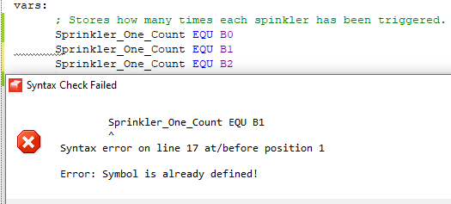
I fixed this by changing each name to unique ones.
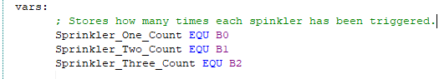

When I was working on the override switch functionality, I accidentally typed “btfsc PORTA 0” instead of “btfsc PORTA, 0”. This resulted in the following syntax error.
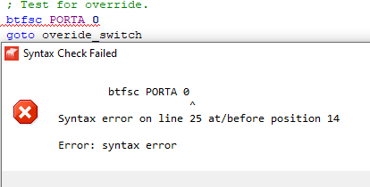
I easily fixed this by changing it to “btfsc PORTA, 0”
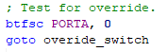
During implementing the sensor one subroutine, I was attempting to store the result of a calculation into the W register, & I got a syntax error when trying to do that with this instruction.
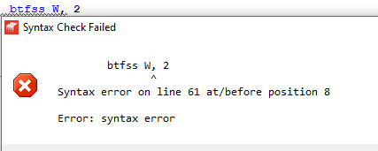
I wasn’t entirely sure why there was an issue with performing btfs* operations on the W register, other than for the reason that it is the working register. To circumnavigate this problem I created another registered to move the value into before checking it.
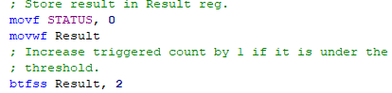
This allowed the program to compile without an issue.

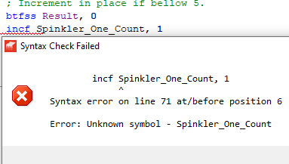
I made a typo when refering to the “Sprinkler_One_Count” register whilst rewritting my sprinkler subroutine. I easily fixed this by correcting the typo.


I made a mistake of calling a subroutine with “goto” instead of “call”, which resulted in a “Stack Underflow” error when I was testing it.
I easily fixed this by changing the “goto” to a “call” instruction.

System Realisation

Block Diagram

Circuit Diagram
The diagrams had to be split into two images (a top & a bottom half) due to limitations with the software I was using.

Testing Configuration
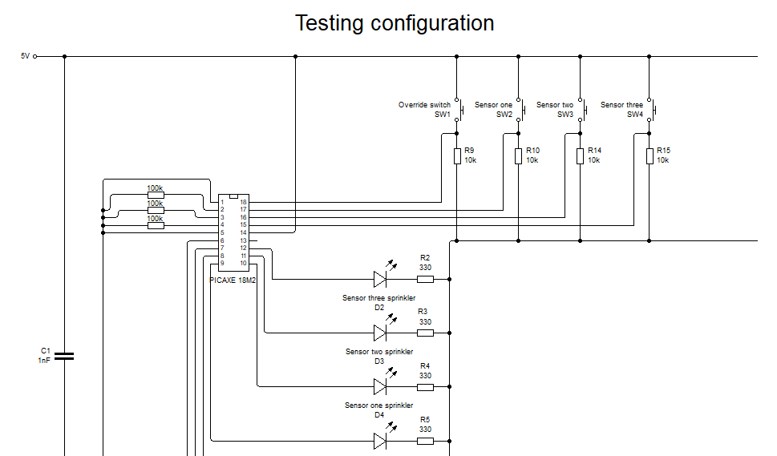

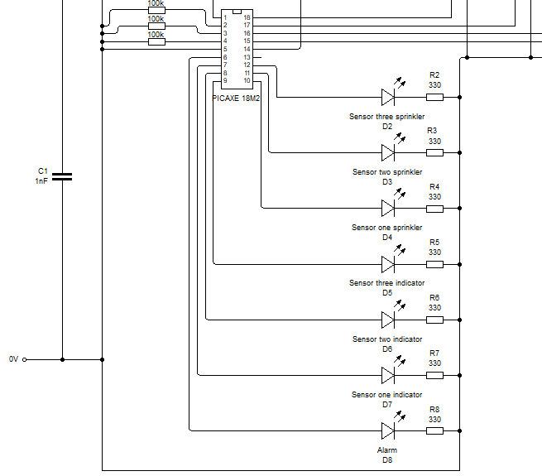

Deployed Configuration
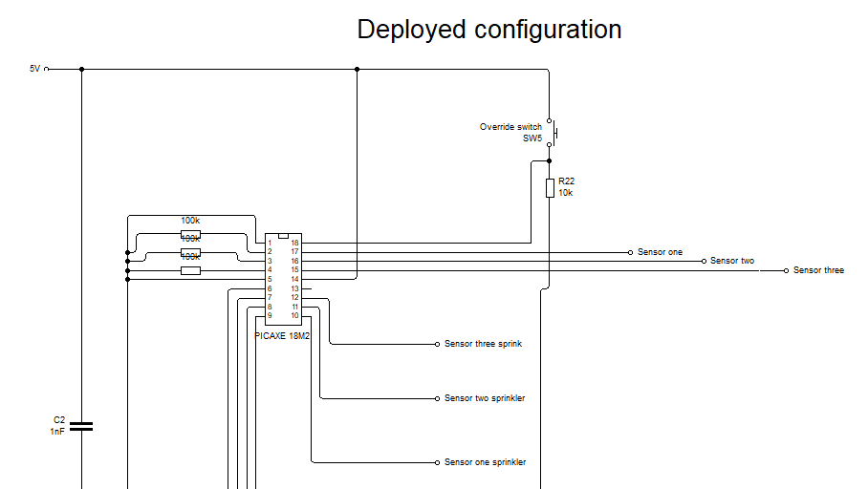
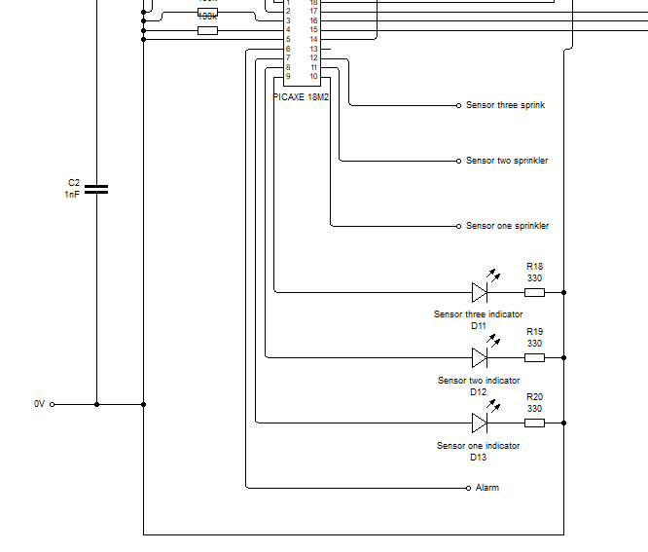

Components List

Photo Of Circuit
Needs to be very well organised, with all wires horizontal or vertical.

Evidence of Downloaded Program
Photo

Test Plan
How all of the circuit will be tested.
All inputs to be assumed low unless explicitly stated otherwise.
Between each test the override switch should be pressed for at least 200ms.
The italic text refers to input & outputs defined in Code Description.
Test | Why | Expected Result | Actual Result
Have sensor one high for over 500ms | To test if sensor one works as expected. | The following outputs will be high: alarm, sensor one indicator, sensor one sprinkler
Have sensor two high for over 500ms | To test if sensor two works as expected. | The following outputs will be high: alarm, sensor two indicator, sensor two sprinkler
Have sensor three high for over 500ms | To test if sensor three works as expected. | The following outputs will be high: alarm, sensor three indicator, sensor three sprinkler
Have sensor one high for 300±100ms  Have sensor one low for at least 100ms  Have sensor one high for 300±100ms  Have sensor one low for at least 100ms  Have sensor one high for 300±100ms | To test that the sensor won’t trigger due to non-consecutive inputs. | All of the outputs will be low.
Have sensor one, sensor two, & sensor three high for over 500ms | If all of the corresponding sensor outputs will be triggered along with the alarm | The following outputs will be high: alarm, sensor one indicator, sensor one sprinkler, sensor two indicator, sensor two sprinkler,  sensor three indicator, sensor three sprinkler
Have sensor one high for over 500ms & the override switch high for the duration of the test | If the override switch stops the sensors from triggering | All of the outputs will be low.
Have the override switch & sensor one high initially. Set the override switch to low after the test has started. | If the sensors can re-trigger after they have been overridden | 500±100ms after the override switch has been released the following outputs will be high: alarm, sensor one indicator, sensor one sprinkler

Test Equipment Circuit Diagram

Results From Test

Analysis Of Test Results
Compare results to the flowchart & explain what this means in regards to the flowchart & system function.

Evaluation

Progress & Performance
Reflect upon the progress & performance

Reliability
How consistently/well did the system work?

Comparison
Compare the test results with the initial specification. Use a table

Improvements
At least 2 suggestions for improvement to the system alongside how they will improve the system.

